Shopping Cart
DFD’S

Level 0 Diagram:

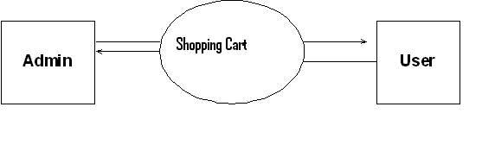

Level 1 Diagram:

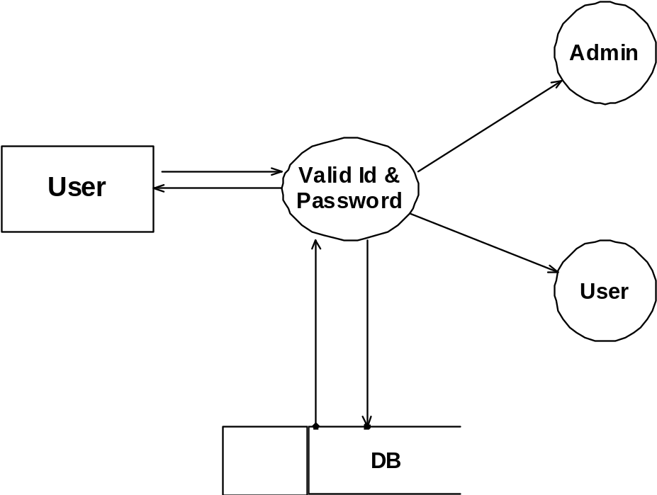

Level 2 Diagram for Admin:

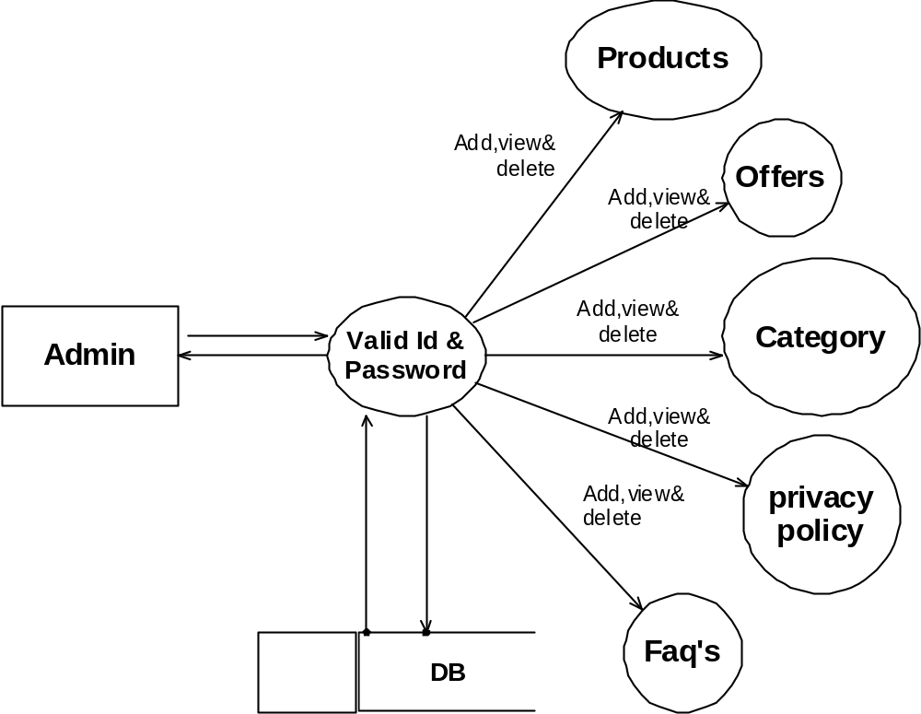

Level 2 Diagram for User:

